**REGISTER FOR IBM CLOUD**

Step 1: Open a browser window and navigate to the IBM Cloud Registration Page.

Step 2: Fill in the registration form and follow the link in the **confirmation email** to confirm your account once it arrives.

Step 3: [Login into IBM Cloud](https://ibm.biz/Bdqu4M) using your account credentials.

Step 4: When prompted, enter your IBM Id (the email ID you used to create the account above) and also enter your Password .

Step 5: Click Log in.

Step 6: When successfully authenticated, the IBM Cloud Dashboard will load.

**LOGIN PAGE:**

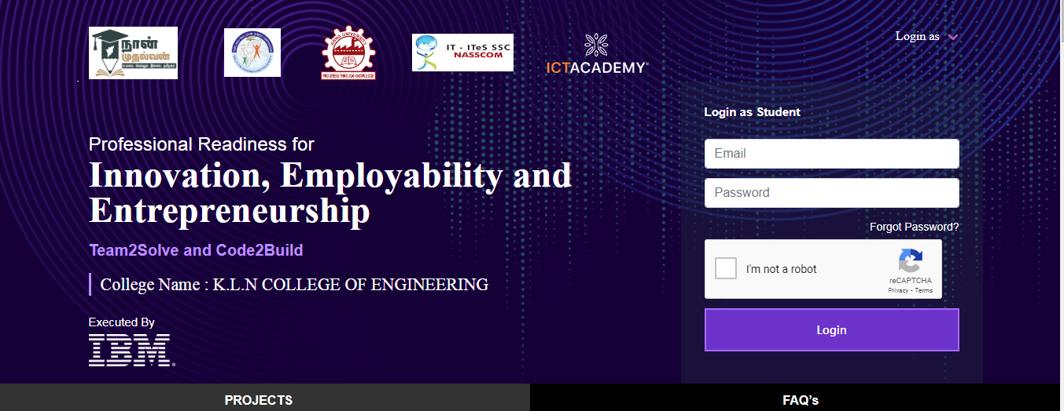

**DASHBOARD SCREEN:**

